Benefits of the graphic standards book:Ensures that the company's visual identity is used consistently across all communication channels. Protects the company's visual identity by setting clear guidelines for its use. It is an important reference tool for the marketing and design teams.

Graphical User Interface (GUI)
Computer EngineeringMCAOperating System

GUI is an interface that allows users to interact with different electronic devices using icons and other visual indicators. The graphical user interfaces were created because command line interfaces were quite complicated and it was difficult to learn all the commands in it.
In today’s times, graphical user interfaces are used in many devices such as mobiles, MP3 players, gaming devices, smartphones etc.
The below diagram provides the position of the graphical user interface with respect to the compute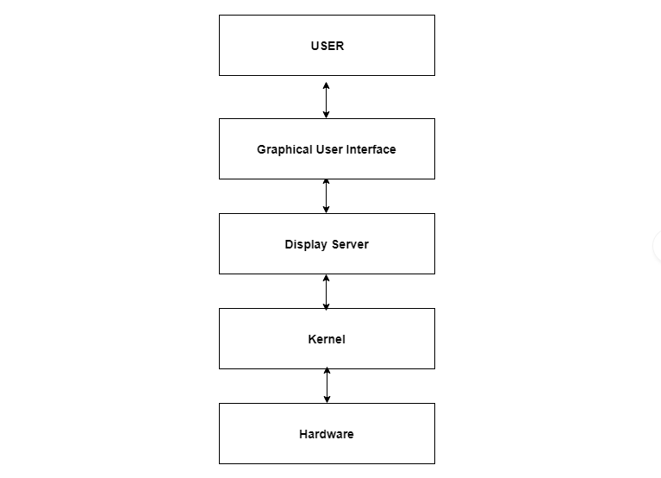r system −

Elements in Graphical User Interface
Graphical User Interface makes use of visual elements mostly. These elements define the appearance of the GUI. Some of these are described in detail as follows −

Window
This is the element that displays the information on the screen. It is very easy to manipulate a window. It can be opened or closed with the click of an icon. Moreover, it can be moved to any area by dragging it around. In a multitasking environment, multiple windows can be open at the same time, all of them performing different tasks.
There are multiple types of windows in a graphical user interface, such as container window, browser window, text terminal window, child window, message window etc.

Menu
A menu contains a list a choices and it allows users to select one from them. A menu bar is displayed horizontally across the screen such as pull down menu. When any option is clicked in this menu, then the pull down menu appears.
Another type of menu is the context menu that appears only when the user performs a specific action. An example of this is pressing the right mouse button. When this is done, a menu will appear under the cursor.

Icons
Files, programs, web pages etc. can be represented using a small picture in a graphical user interface. This picture is known as an icon. Using an icon is a fast way to open documents, run programs etc. because clicking on them yields instant access.

Controls
Information in an application can be directly read or influences using the graphical control elements. These are also known as widgets. Normally, widgets are used to display lists of similar items, navigate the system using links, tabs etc. and manipulating data using check boxes, radio boxes etc.

Tabs
A tab is associated with a view pane. It usually contains a text label or a graphical icon. Tabs are sometimes related to widgets and multiple tabs allow users to switch between different widgets. Tabs are used in various web browsers such as Internet Explorer, Firefox, Opera, Safari etc. Multiple web pages can be opened in a web browser and users can switch between them using tabs.

Essential GUI design principles
June 1, 2023 10 min read
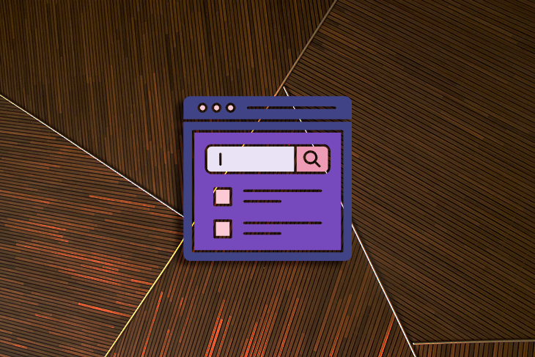
Have you ever used a computer or a mobile app and thought to yourself, “Wow, this is really easy to use”? Chances are, that product has a well-designed Graphical User Interface (GUI).
GUI design is a fundamental aspect of creating user-friendly digital products. It’s all about designing an engaging and intuitive visual interface that allows users to interact with the product with ease. It’s the reason you know to click on a button or swipe in a particular direction. Without a good GUI design, using a digital product can be confusing and frustrating.
In this article, we’ll cover essential GUI design principles like consistency, simplicity, and feedback, and explore how you can apply them to your own designs. And of course, we’ll touch on important considerations like accessibility and user testing. By the end of this article, you’ll have a solid understanding of how GUI design can help you create digital products that users will love.

Table of contents
- Principle 1: Consistency
- Principle 2: Simplicity
- Principle 3: Feedback
- Accessibility considerations
- User testing
- Comparison to other design principles

Principle 1: Consistency
Consistency is a key principle in GUI design that refers to the use of consistent visual elements, layout, and navigation throughout a digital product. A consistent GUI design makes it easier for users to understand and navigate the product, regardless of the context or section they are in.
When users interact with a digital product, they learn how to use it based on their past experiences with the product. This is also known as external consistency, and it can be achieved by using the same design patterns, conventions, and terminology across different products or interfaces.
External consistency makes it easier for users to understand and navigate a new product or interface, even if they have never used it before. Inconsistent design across a GUI can lead to confusion and frustration for users.

Visual elements
Visual consistency ensures users can easily recognize different sections and content types throughout the product. For example, using a consistent color scheme and typography across a website can help users quickly identify different types of content, such as headings, paragraphs, and links. If the color scheme or typography is inconsistent, users may struggle to differentiate between different content types, leading to confusion and frustration.
Apple’s Human Interface Guidelines provide several design best practices to follow in order to maintain visual consistency across graphical user interfaces. In this example, they provide guidance on keeping consistent sizing and stroke weight when using iconography.
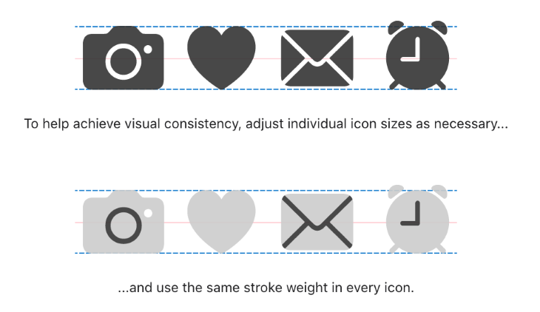Source: Design — Apple Developer

Layout
Layout consistency creates a sense of familiarity and predictability for users. Users are more likely to enjoy using a product when they can anticipate the location and placement of different elements. Consistent placement of navigation menus, search bars, and other interactive elements makes it easier for users to find what they are looking for and reduces frustration associated with searching for information.
Effective layouts use grouping, margins, spacers, and padding to visually arrange elements in a certain way and direct the user’s attention toward the most important information on the screen.
Google’s open-source design system, Material Design, provides extensive guidelines for designing consistent layouts, breaking down the different parts of a layout, and effectively using spacing to create a polished GUI design.
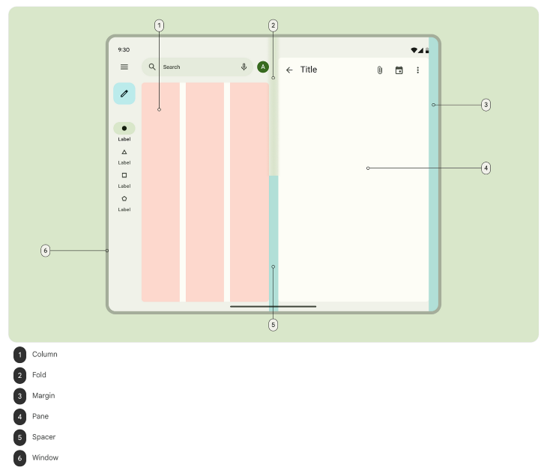Source: Material Design

Navigation
Navigation consistency ensures that users can easily find what they are looking for, regardless of where they are on the product. By using the same navigation elements and patterns throughout the product, whether it be tabs, trees, or breadcrumbs, users can easily navigate between different sections, pages, or screens. If the navigation patterns are inconsistent, users may struggle to find what they are looking for, leading to frustration and confusion.



Over 200k developers and product managers use LogRocket to create better digital experiences
Learn more →

A great example of navigation consistency is Amazon.com. Their header contains a wide search bar across the top, as well as links to account settings and order information that are visible on every page. Their navigation menu underneath also appears on every page, so users can easily access it at their convenience.
Source: Amazon.com

Using design systems to implement consistency
A design system is a collection of reusable design elements, such as colors, typography, and icons, and components, such as dropdowns, accordions, and panels, that are leveraged by products to design consistent interfaces and experiences.
Design systems provide a set of predefined design elements that have been tested and approved to provide an accessible, consistent look and feel, as well as interaction across a design. By following the guidelines of an established design system, designers can speed up the design process, maintain consistency over time, and promote collaboration between designers and developers.

Principle 2: Simplicity
When a design is simple and easy to understand, users are more likely to explore and interact with the product.
Simplicity in GUI design not only makes a digital product easy to use, but it can also improve user engagement. This increased engagement can lead to higher usage rates and increased user satisfaction.
On the other hand, a cluttered or confusing design can lead to frustration and reduced engagement, which can result in users abandoning the product.
A simple design can also create a sense of trust and credibility with users. If a product is easy to use and understand, users are more likely to trust the product and the company behind it. This can lead to increased loyalty and positive word-of-mouth marketing.

Minimalism
One important component of simplicity in GUI design is minimalism. This means removing any unnecessary design elements and focusing only on what’s essential.
For example, a designer can avoid cluttering a screen by including only the most important actions and information. This involves understanding your user’s needs and goals and ensuring that the GUI helps them in achieving their goals without distracting them.
A classic example of minimalism is Google Search. The page uses a lot of white space to focus the attention on the search bar in the center of the screen. Users come to this page to search for information and the minimalistic design doesn’t distract them from achieving their goal.
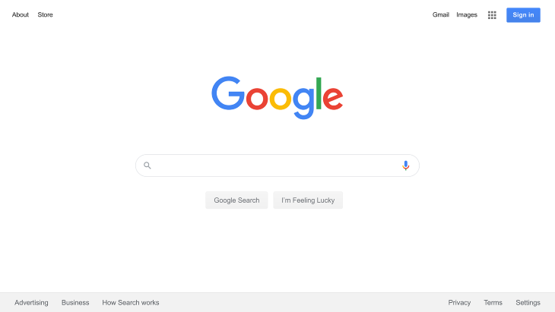Source: Google

Clarity
Clarity is another critical aspect of simplicity in GUI design. A design should be clear and easy to understand at a glance. This can be achieved by using clear labels, typography, and visual hierarchy to guide the user’s attention to the most important elements of the design.
Unclear GUI design can lead to users not knowing how to properly engage with the product and leave them searching for documentation or ultimately abandoning the product if they can’t figure out their way around it.
Airbnb’s website attaches clear labels to its navigation menu. Their use of unique iconography can be unclear to users, because the icons can appear abstract or complex. The labels underneath each icon ensure that users understand what each icon means, helping them make a decision on which to select.
Source: Airbnb

Ease of use
Ease of use is also a crucial element in simplicity. A digital product should be easy to use, even for first-time users. This can be achieved by reducing the number of steps required to complete a task and using familiar design patterns.
Using progressive disclosure and onboarding experiences, such as tooltip walkthroughs, can aid users in completing tasks for the first time, which helps them learn the product more quickly.
Google Analytics uses a tooltip walkthrough to bring awareness to users of different features. The GUI can be a bit overwhelming at first glance, so the tooltips bring attention subtly without causing too much disruption. After seeing the tooltip, users will know where to find the feature when they want to use it next.
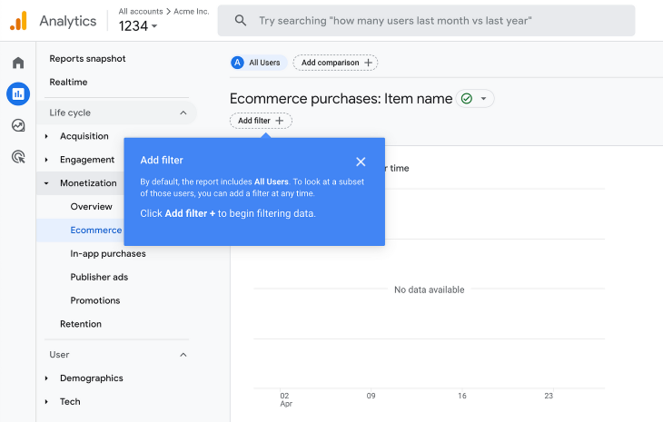Source: Google Analytics

Principle 3: Feedback
In addition to consistency and simplicity, feedback is another crucial aspect of GUI design. Feedback can be provided in various forms such as visual cues, status indicators, and error messages. These feedback elements help users understand the state of the product and provide guidance on how to interact with it.
Feedback reduces confusion and frustration, and creates a sense of trust and credibility with users. Effective feedback can help users learn how to use a product while also providing clarity into things that go wrong.

Visual cues
Visual cues are an essential form of feedback that helps users understand which elements are interactive and respond to user input. For example, when a user hovers over a button, the button may change color or display a tooltip, indicating that it is clickable. Visual cues can also help users understand the context of the product, such as the current state of a task or process.
The Goldman Sachs Design System has built visual cues into its design components. For example, their drag-and-drop component features several visual cues. The cursor changes from an open hand to a closed hand when an item is being grabbed.
Feedback is also provided by adding elevation and a blue border around the grabbed item. Furthermore, the droppable placeholder area becomes a darker shade to inform the user that the item will be dropped into the area when it is released.
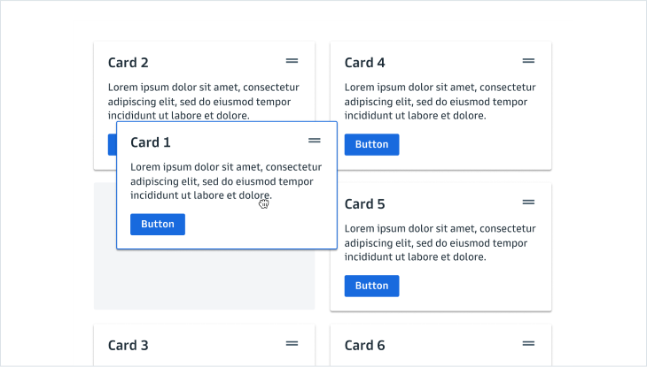Source: Goldman Sachs Design System

Status indicators
Status indicators are another essential form of feedback that informs the user about the ongoing process. For example, when uploading files, a progress bar can provide feedback to the user such as the percentage of the upload completed or an estimated time for the upload to complete. This type of feedback helps users understand that the product is working and responding to their input.
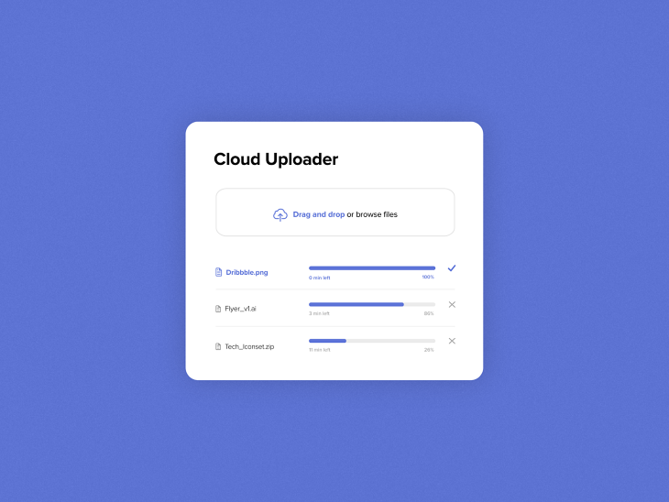Source: Niklas Luther on Dribbble

Messaging
Messages are an essential form of feedback that informs the user of the result of an action, whether invoked by the user or the system. Effective messages should be clear and concise, and be written following your product’s voice and tone guidelines.
Urgent feedback can appear in components such as callouts or dialogs that focus the user’s attention on the message and can be manually dismissed. Less urgent feedback can be displayed in a toast notification that automatically dismisses after a few seconds.
In the case of an error message, avoid blaming the user and provide actionable steps to resolve the issue. A well-designed error message should be written in a way that anyone can understand. It should inform the user about what went wrong, how to fix it, and prevent it from happening again.
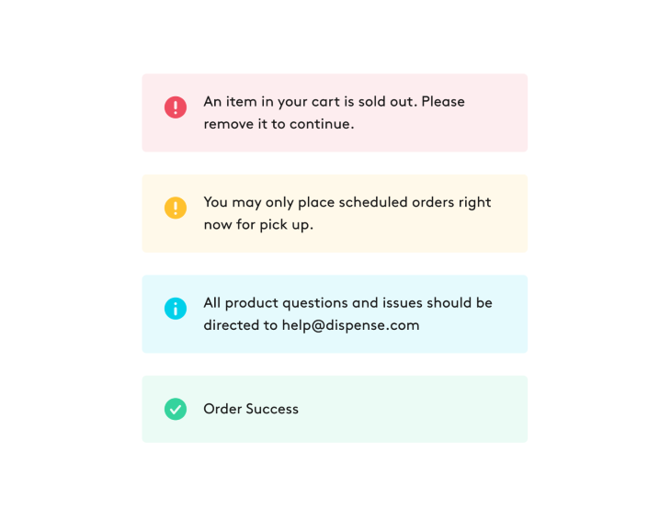Source: Chelsea Officer on Dribbble

Accessibility considerations
Accessibility in GUI design refers to the ability of all users, regardless of any disabilities they may have, to access and interact with a digital product. There are several key accessibility considerations that designers must take into account when creating a GUI design.

Color contrast
One of the key accessibility considerations is color contrast. A GUI design with low contrast can be difficult for users with visual impairments to read.
Proper color contrast can make text and other elements stand out and be easily distinguishable from the background. This helps people with color blindness or low vision read and interact with the product more easily and efficiently. For instance, using dark text on a light background or vice versa can provide the necessary contrast for users with visual impairments to read text clearly.
Use a color contrast checker to ensure that your GUI designs pass WCAG AA accessibility standards. In the example below, the foreground and background colors have a contrast ratio of 5.01:1, which passes WCAG AA level of compliance.
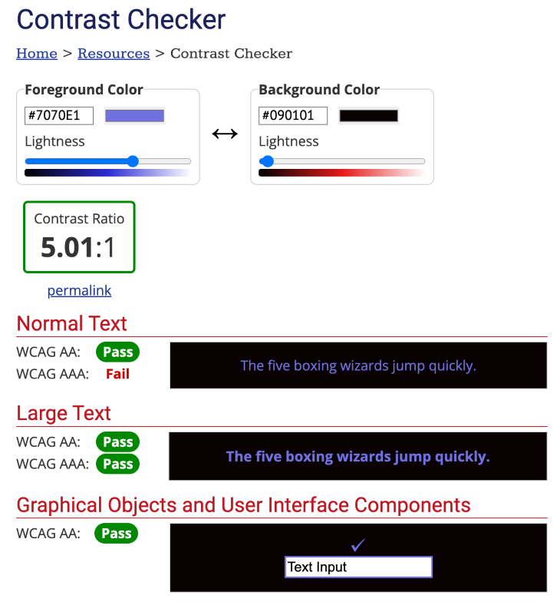Source: WebAIM

Typography
Another consideration is typography, as it can also affect the readability of a digital product. It is important to use appropriate font sizes, styles, and spacing to ensure that users can read the content easily. A good rule of thumb is to use a minimum of 16px for body text without using a font size below 12px.

Keyboard navigation
Keyboard navigation is also a critical accessibility consideration. Some users may have difficulty using a mouse, so keyboard navigation can make it easier for them to interact with a digital product.
Designers should ensure that all interactive elements, such as buttons and links, can be accessed and activated using the keyboard alone. In addition, interactive elements should be labeled with clear descriptions so that they can be read aloud by a screen reader.
By considering these accessibility factors during GUI design, designers can make digital products more accessible to users with disabilities. This, in turn, can increase the product’s usability and appeal to a wider audience.

User testing
User testing involves conducting tests with users to evaluate the usability of a digital product and identify areas for improvement. By observing how real users interact with a product, designers can gain valuable insights into what users are frustrated with and how to improve the user experience.
User testing can take many forms, including surveys, interviews, and usability testing. Surveys and interviews can provide valuable feedback on users’ opinions and preferences, while usability testing involves watching users interact with a product and observing their behavior and feedback.
Without conducting user testing, designers are essentially designing in a vacuum, with no real understanding of how users will interact with their products. User testing can reveal issues with usability, confusing layouts, and unclear instructions.
Examples of common user testing methods include A/B testing, which involves presenting users with different versions of a product to see which performs better, and task analysis, which involves observing users as they complete tasks and identifying areas of confusion or difficulty.
By conducting user testing, designers can make informed decisions about how to improve their products, resulting in a better user experience and increased user satisfaction.

Comparison to other design principles
While GUI design is a distinct discipline, it shares some similarities with other types of design, such as industrial design and graphic design. These design principles are grounded in the idea of creating functional, user-friendly products, but each field has its own unique considerations and requirements.

GUI vs. industrial design
Industrial design is concerned with the design of physical products such as furniture, appliances, and vehicles. Similar to GUI design, industrial design emphasizes the importance of simplicity and user-friendliness.
Braun, a German consumer products company, is known for its sleek and minimalist industrial designs, particularly in its household products such as radios, shavers, and kitchen appliances. Braun’s design philosophy is centered around the idea that good design should be both functional and aesthetic, with a focus on simplicity and ease of use.
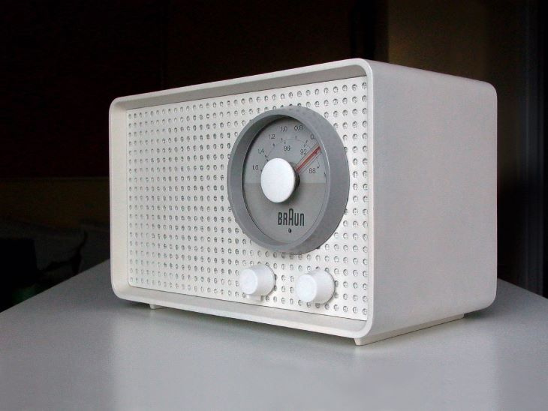Braun SK 2 Radio (1960) (Source: Wikipedia)
The field of industrial design encompasses a range of considerations, including materials, manufacturing processes, and safety regulations, that don’t apply to GUI design.
However, industrial designers do share a common concern with GUI designers in that they strive to create products that are user-friendly and comfortable to use. In particular, industrial designers focus on the ergonomics of their designs, which involves making sure that their products are easy to handle, interact with, and operate.
Similarly, GUI designers focus on the usability of their digital products, taking care to ensure that users can easily navigate and interact with the interface.

GUI vs. graphic design
Unlike GUI design, graphic design is focused on creating visual communication materials such as logos, advertisements, and website layouts.
But both fields of design emphasize consistency and simplicity. They also consider factors such as typography, color theory, and visual hierarchy. They must ensure that their designs effectively communicate the desired message to their target audience.
The famous I Love New York logo designed by Milton Glaser (Source: Milton Glaser)
Despite the similarities and differences, all design disciplines share the goal of creating functional, user-friendly products. They all strive to make their products easy to use and visually appealing, and they all consider the needs and preferences of their users. Additionally, they all recognize the importance of testing their designs with real users to ensure that they are effective and enjoyable to use.

Conclusion
Consistency, simplicity, and feedback are key principles of GUI design that help to enhance user experience and engagement. By incorporating these principles into their work, designers can ensure that their digital products are intuitive, easy to use, and accessible to all users

Getting started with OpenGL

G
GFGWRITEBOT

• Read
• Discuss
• Courses

Open Graphics Library (OpenGL) is a cross-language (language independent), cross-platform (platform-independent) API for rendering 2D and 3D Vector Graphics(use of polygons to represent image). OpenGL API is designed mostly in hardware.
- Design : This API is defined as a set of functions which may be called by the client program. Although functions are similar to those of C language but it is language independent.
- Development : It is an evolving API and Khronos Group regularly releases its new version having some extended feature compare to previous one. GPU vendors may also provide some additional functionality in the form of extension.
- Associated Libraries : The earliest version is released with a companion library called OpenGL utility library. But since OpenGL is quite a complex process. So in order to make it easier other library such as OpenGL Utility Toolkit is added which is later superseded by free glut. Later included library were GLEE, GLEW, and gliding.
- Implementation : Mesa 3D is an open source implementation of OpenGL. It can do pure software rendering and it may also use hardware acceleration on BSD, Linux, and other platforms by taking advantage of Direct Rendering Infrastructure.
Install OpenGL on Ubuntu
For installing OpenGL on Ubuntu, just execute the following command (like installing any other thing) in terminal :
sudo apt-get install freeglut3-dev
For working on Ubuntu operating system:
gcc filename.c -lGL -lGLU -lglut
where filename.c is the name of the file
with which this program is saved.
Install OpenGL on windows in Code::Blocks
- Download code block and install it
- Go to the link and download zip file from the download link that appears after freeglut MinGW package with having link name as Download freeglut 3.0.0 for MinGW and extract it.
- Open notepad with run as administrator and open file from
  - This PC > C:(C-drive) > Program Files(x86) > CodeBlocks > share > CodeBlocks > templates, (then click to show All Files)
  - Next, open glut.cbp and search all glut32 and replace with freeglut.
  - Then, open from This PC > C:(C-drive) > Program Files(x86) > CodeBlocks > share > CodeBlocks > templates > wizard > glut (then click to show All Files)
  - Open wizard.script and here, also replace all glut32 with freeglut
- Then go to freeglut folder (where it was downloaded) and
  - Include > GL and copy all four file from there
  - Go to This PC > C:(C-drive) > Program Files(x86) > CodeBlocks > MinGW > include > GL and paste it.
  - Then, from download folder freeglut > lib, copy two files and go to This PC > C:(C-drive) > Program Files(x86) > CodeBlocks > MinGW > lib and paste it.
  - Again go to downloaded folder freeglut > bin and copy one file (freeglut.dll) from here and go to This PC > C:(C-drive) > Windows > SysWOW64 and paste this file.
- Now open Code::Blocks.
  - Select File > New > Project > GLUT project > Next.
  - Give project title anything and then choose Next.
  - For selecting GLUT’s location : This PC > C:(C-drive) > Program Files(x86) > CodeBlocks > MinGW.
  - Press OK > Next > Finish.
Now, Code::Blocks is ready to test for OpenGL File.
Demonstrate working with OpenGL
To show how OpenGL works, a simple program of circle – drawing is added in C using OpenGL platform.
- C
// C program to demonstrate
// drawing a circle using
// OpenGL
#include<stdio.h>
#include<GL/glut.h>
#include<math.h>
#define pi 3.142857

// function to initialize
void myInit (void)
{
// making background color black as first
// 3 arguments all are 0.0
glClearColor(0.0, 0.0, 0.0, 1.0);

// making picture color green (in RGB mode), as middle argument is 1.0
glColor3f(0.0, 1.0, 0.0);

// breadth of picture boundary is 1 pixel
glPointSize(1.0);
glMatrixMode(GL_PROJECTION);
glLoadIdentity();

// setting window dimension in X- and Y- direction
gluOrtho2D(-780, 780, -420, 420);
}

void display (void)
{
glClear(GL_COLOR_BUFFER_BIT);
glBegin(GL_POINTS);
float x, y, i;

// iterate y up to 2*pi, i.e., 360 degree
// with small increment in angle as
// glVertex2i just draws a point on specified co-ordinate
for ( i = 0; i < (2 * pi); i += 0.001)
{
// let 200 is radius of circle and as,
// circle is defined as x=r*cos(i) and y=r*sin(i)
x = 200 * cos(i);
y = 200 * sin(i);

glVertex2i(x, y);
}
glEnd();
glFlush();
}

int main (int argc, char** argv)
{
glutInit(&argc, argv);
glutInitDisplayMode(GLUT_SINGLE | GLUT_RGB);

// giving window size in X- and Y- direction
glutInitWindowSize(1366, 768);
glutInitWindowPosition(0, 0);

// Giving name to window
glutCreateWindow("Circle Drawing");
myInit();

glutDisplayFunc(display);
glutMainLoop();
}
To compile the above program in Ubuntu,
gcc filename.c -lGL -lGLU -lglut -lm
where filename.c is the name of the file
with which this program is saved.
Output of above program is shown in below screenshot
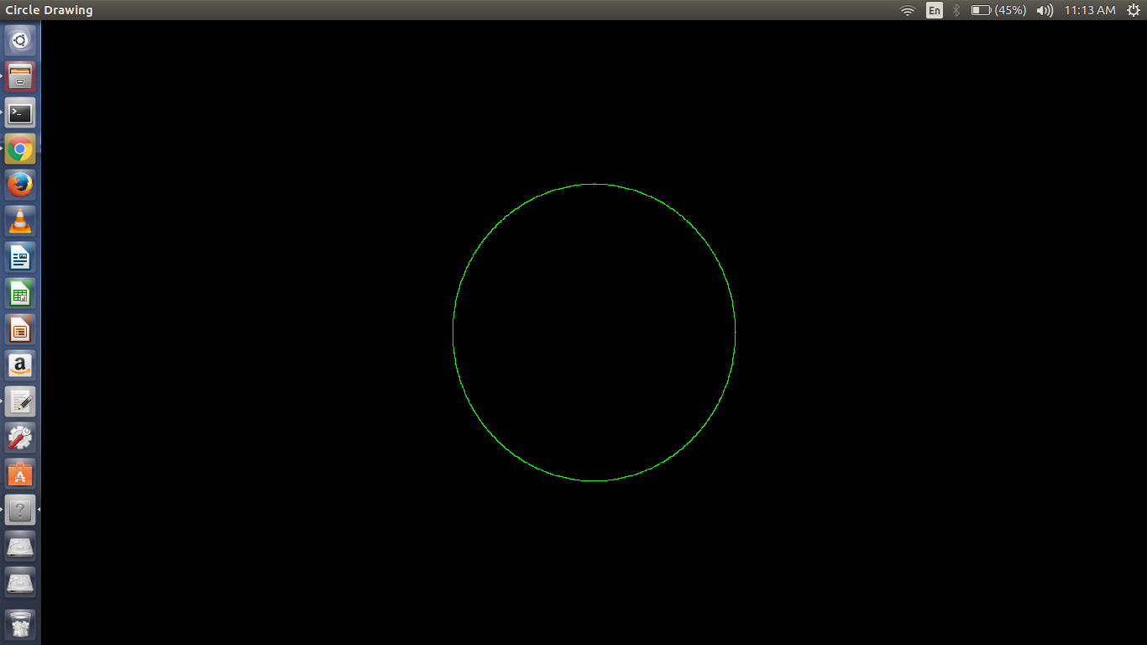
Reference for installation in Code::Blocks : https://www.youtube.com/watch?v=NPcnymtP2SE
This article is contributed by Aditya Kumar. If you like GeeksforGeeks and would like to contribute, you can also write an article using write.geeksforgeeks.org or mail your article to review-team@geeksforgeeks.org. See your article appearing on the GeeksforGeeks main page and help other Geeks.
Please write comments if you find anything incorrect, or you want to share more information about the topic dis

